Practical No 2

C

def common(L1,L2):

result=False

for x in L1:

for y in L2:

if x==y:

result=True

return result

else:

return result

print(common([10,20,30,40],[10,20,30,40]))

print(common([20,30,100,200],[10,67,30,40]))

D

List1=[10,20,30,40,8,7,8,9,1]

List1=List1[5:]

del(List1[5:])

print(List1)

E

List1=[10,20,30,40,8,7,8,9,1]

List2=List1.copy()

print(List2)

F



G

print('Sakshi')

def histo(items):

for n in items:

output=" "

times=n

while times>0:

outpu+="\*"

times=times-1

print(output)

histo([4,9,7])

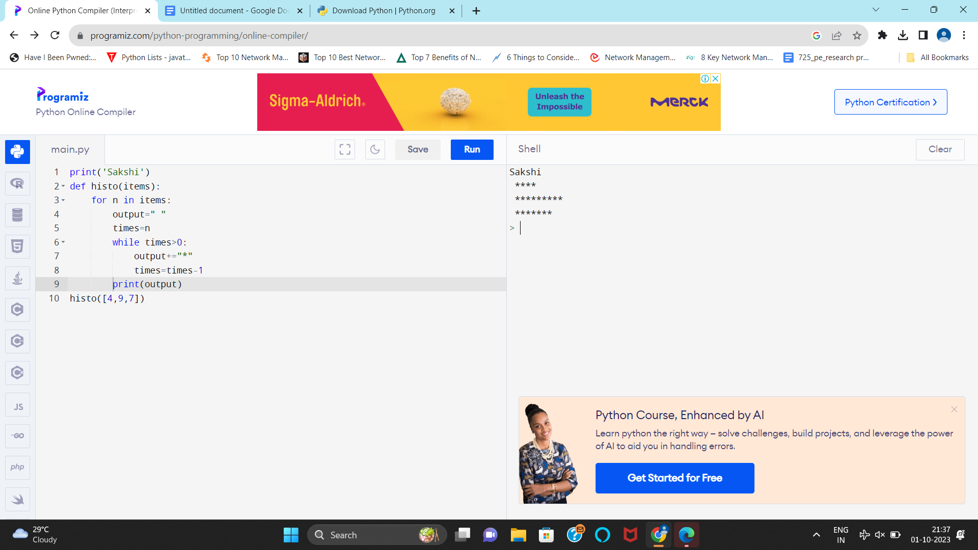

Practical No 1

C



D



E

aa

F

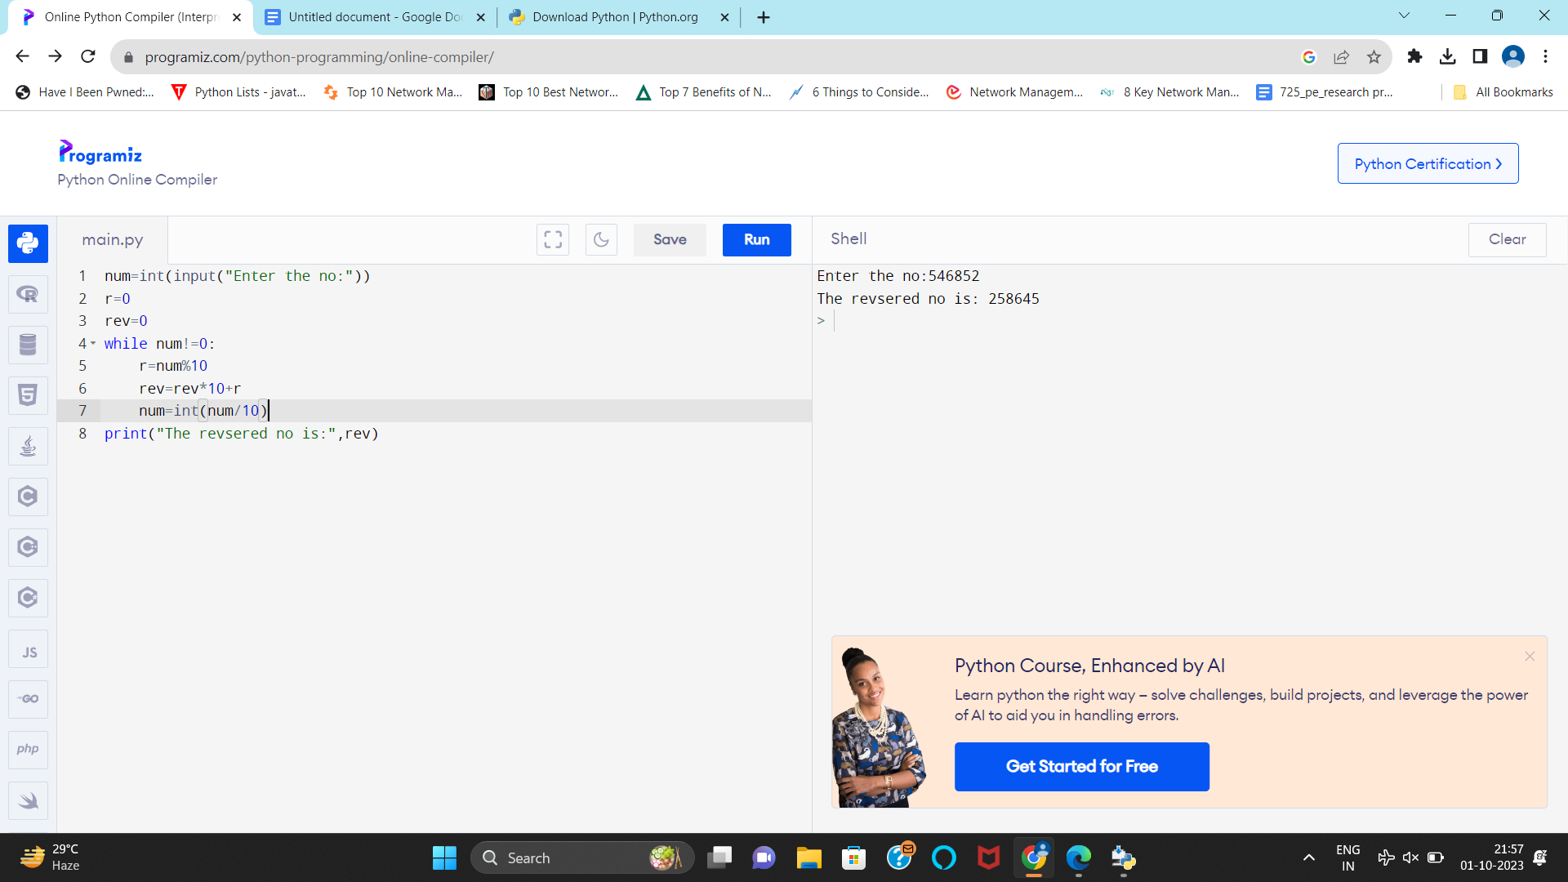

G



H

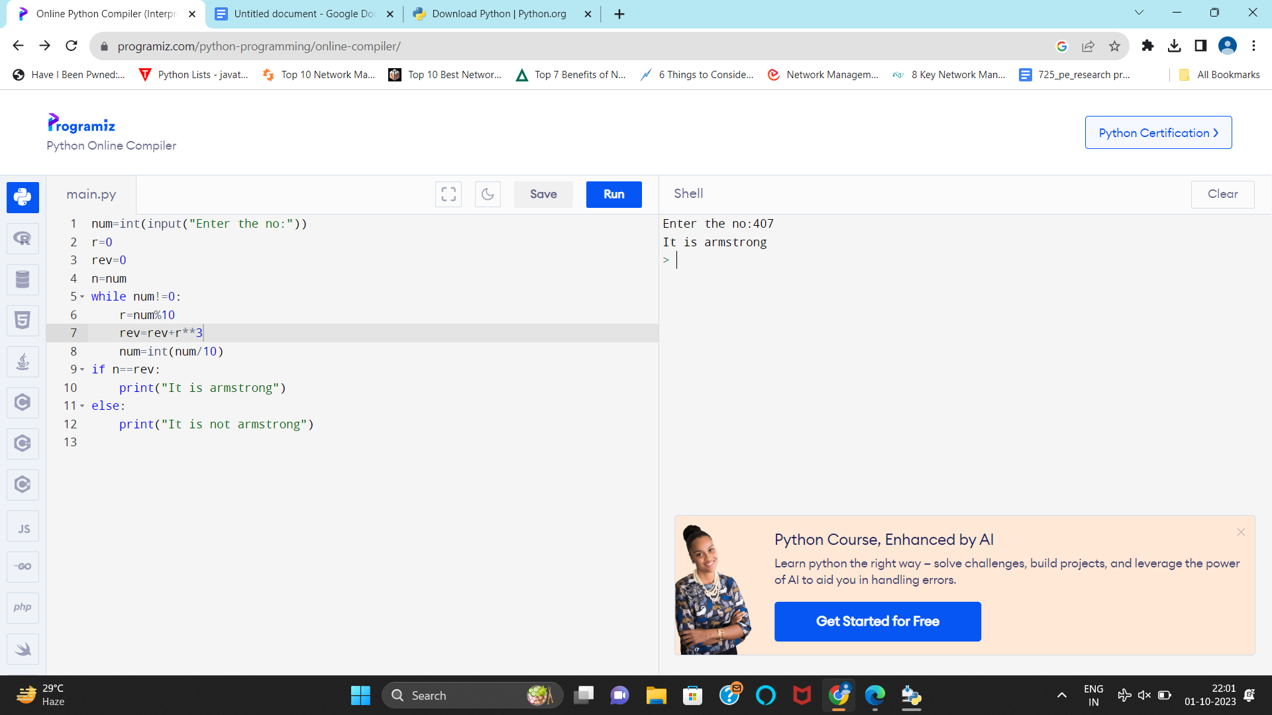

I

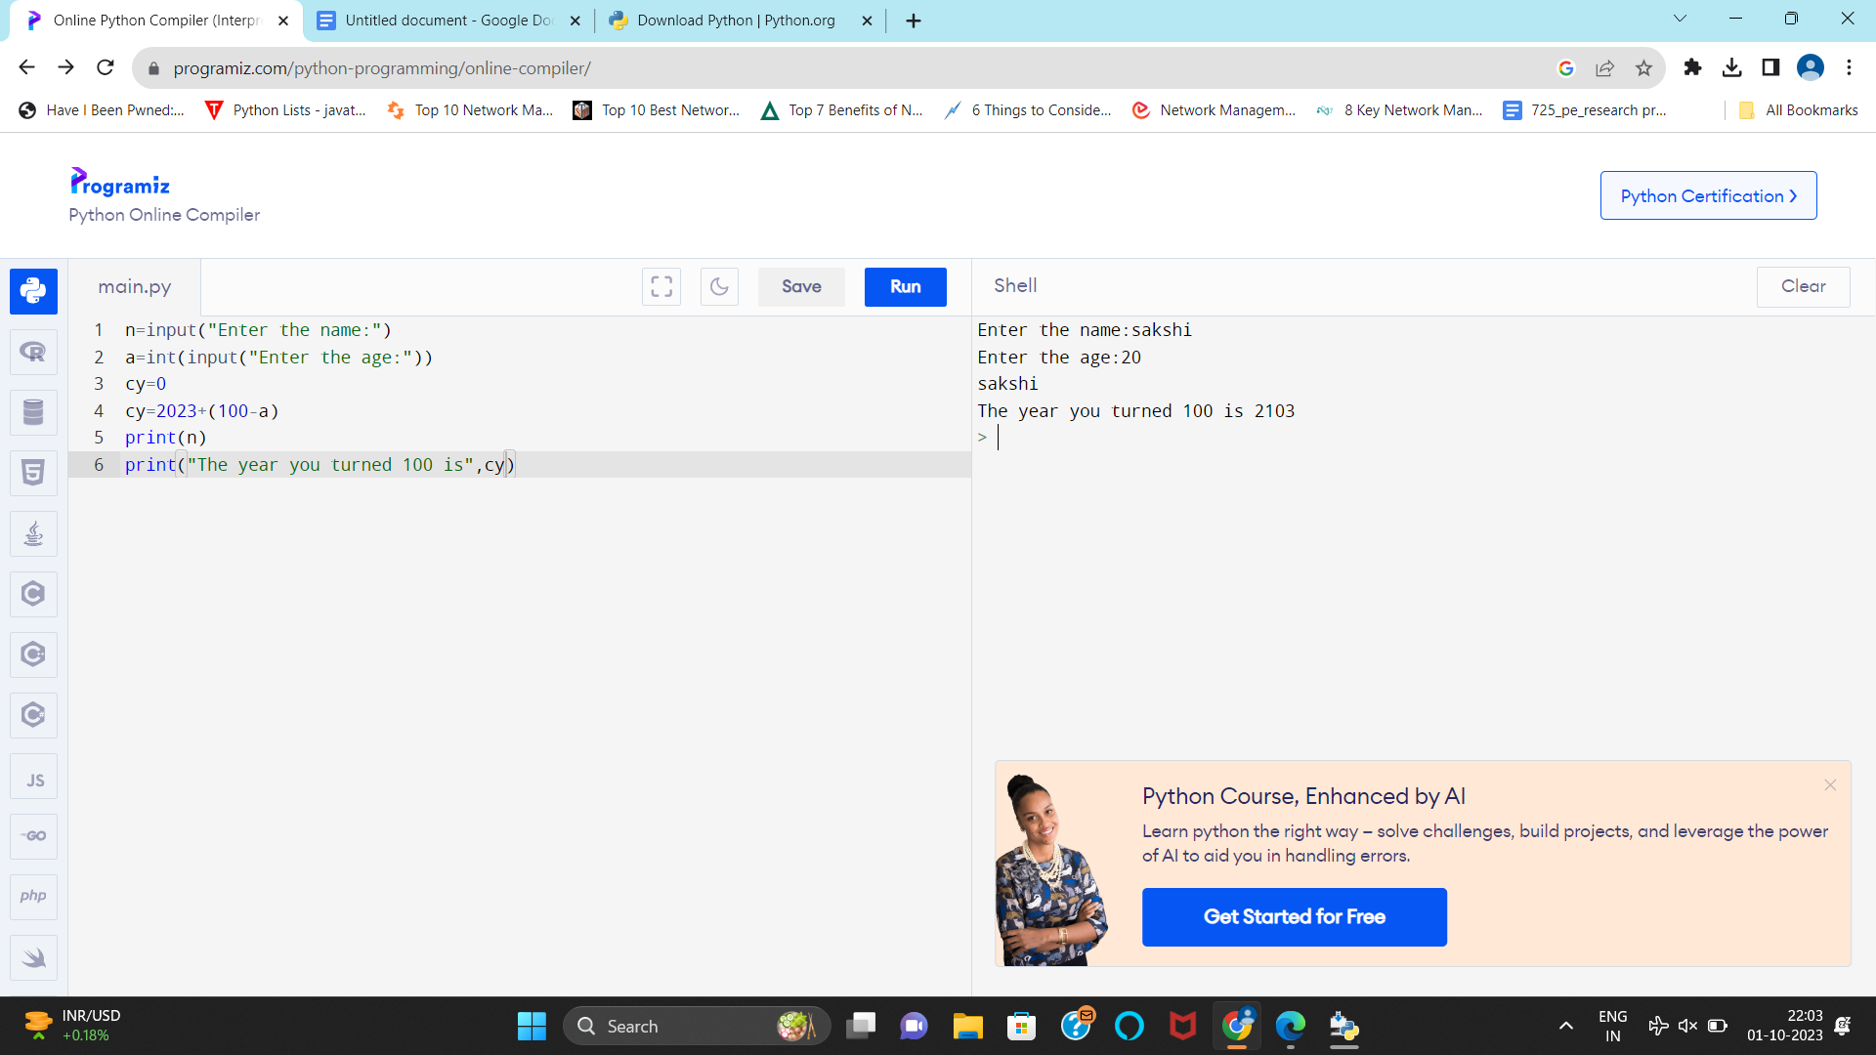

Practical No 3

A

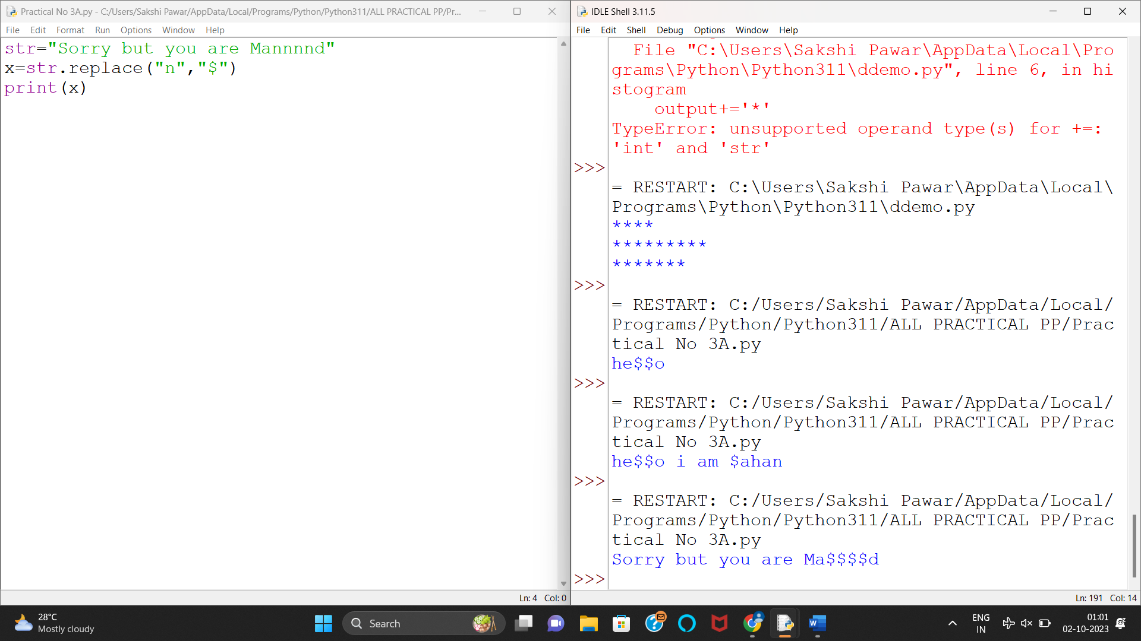

B

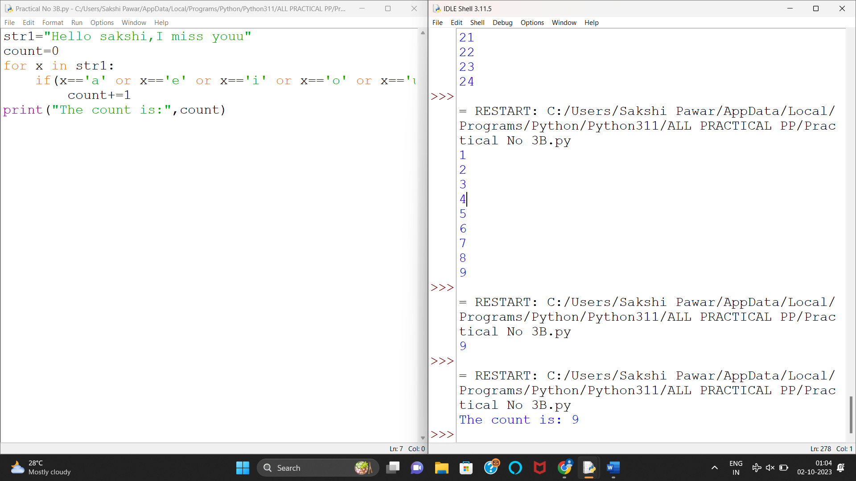

C

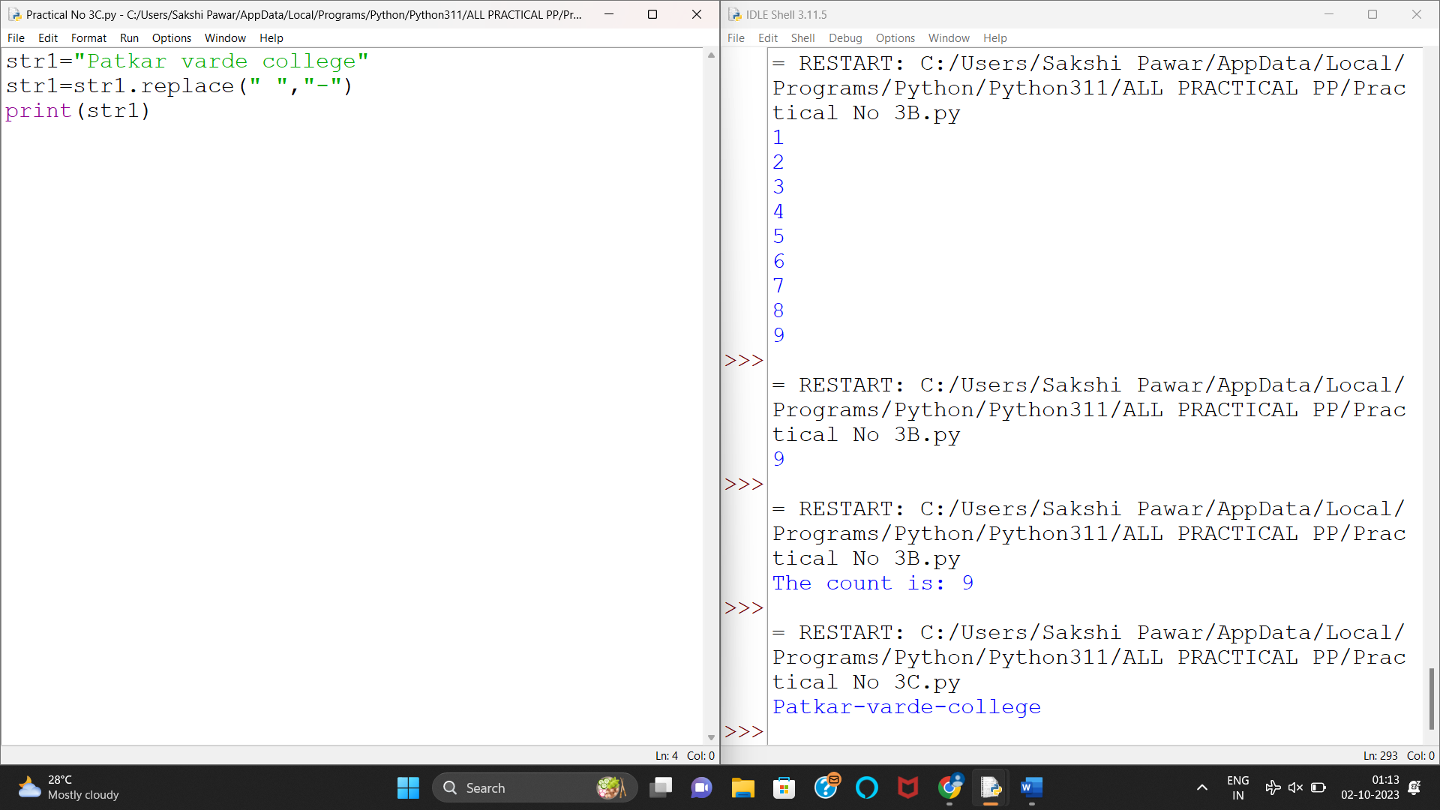

D

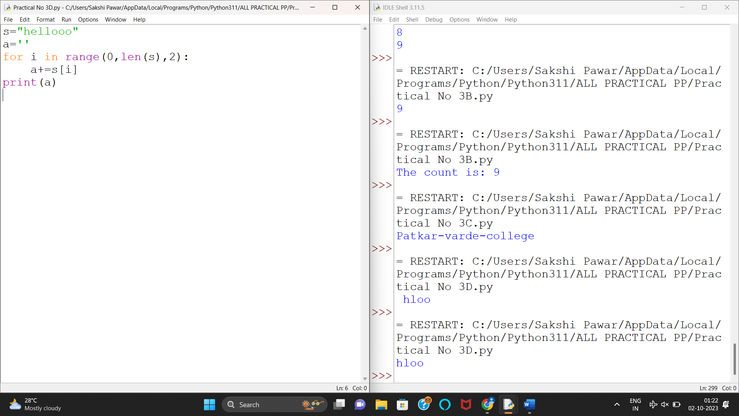

F

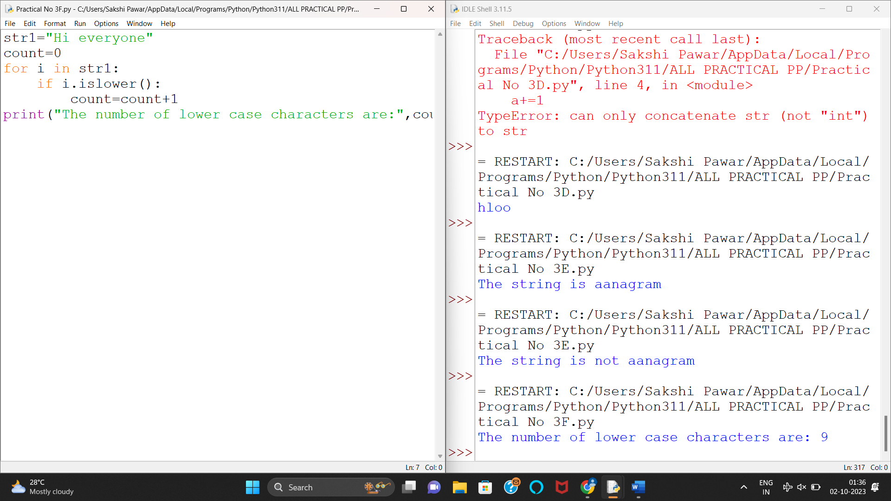

G

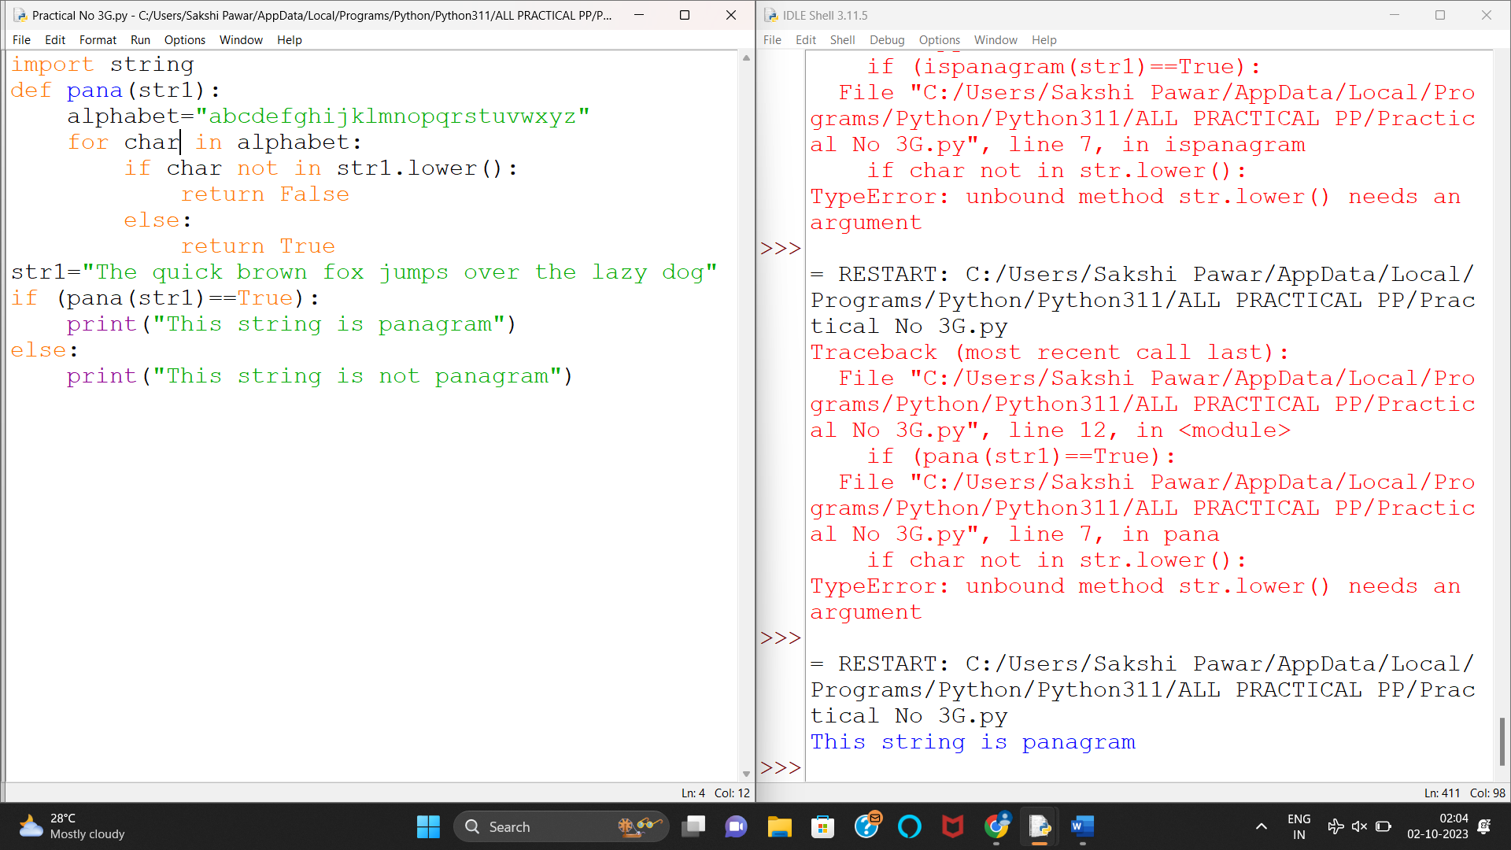

H

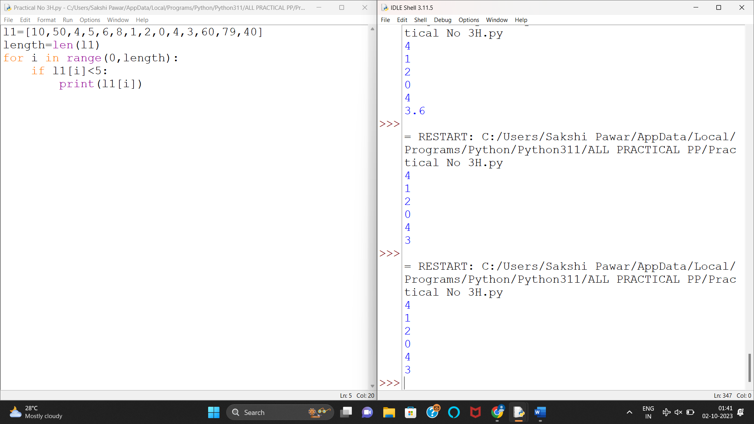

E

